Lunar Year
# Source: AI Source: Provided by: [Data Path: Persons Table -> ID Column: 1, Name_En Column: Motasem Essam] -> From: [ChatGPT] on [7/17/2026]
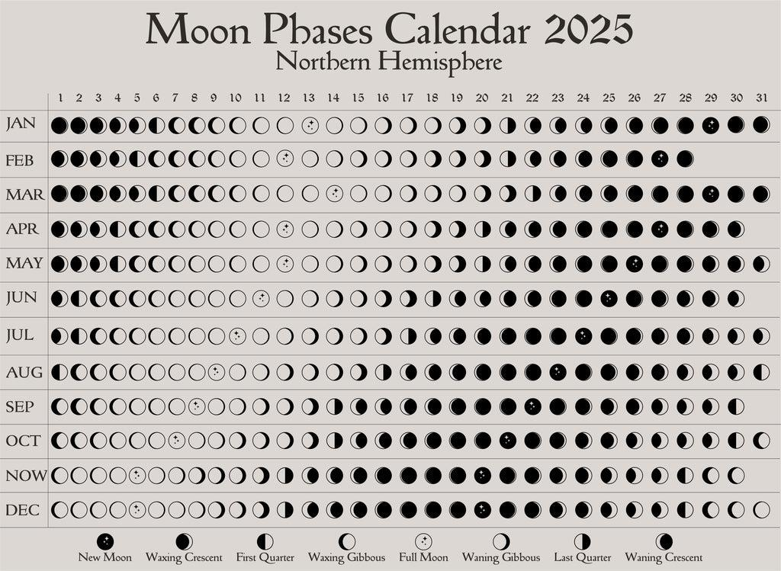
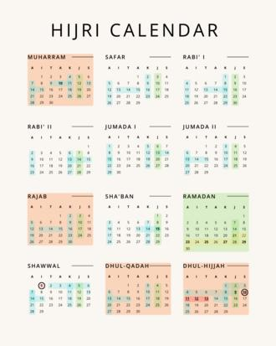
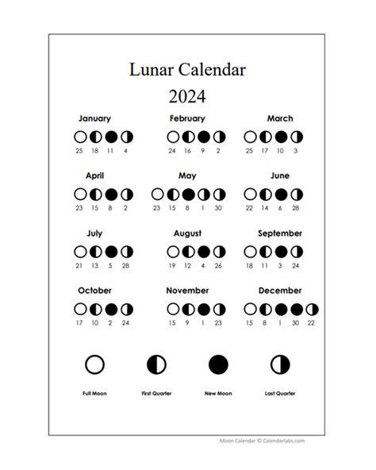
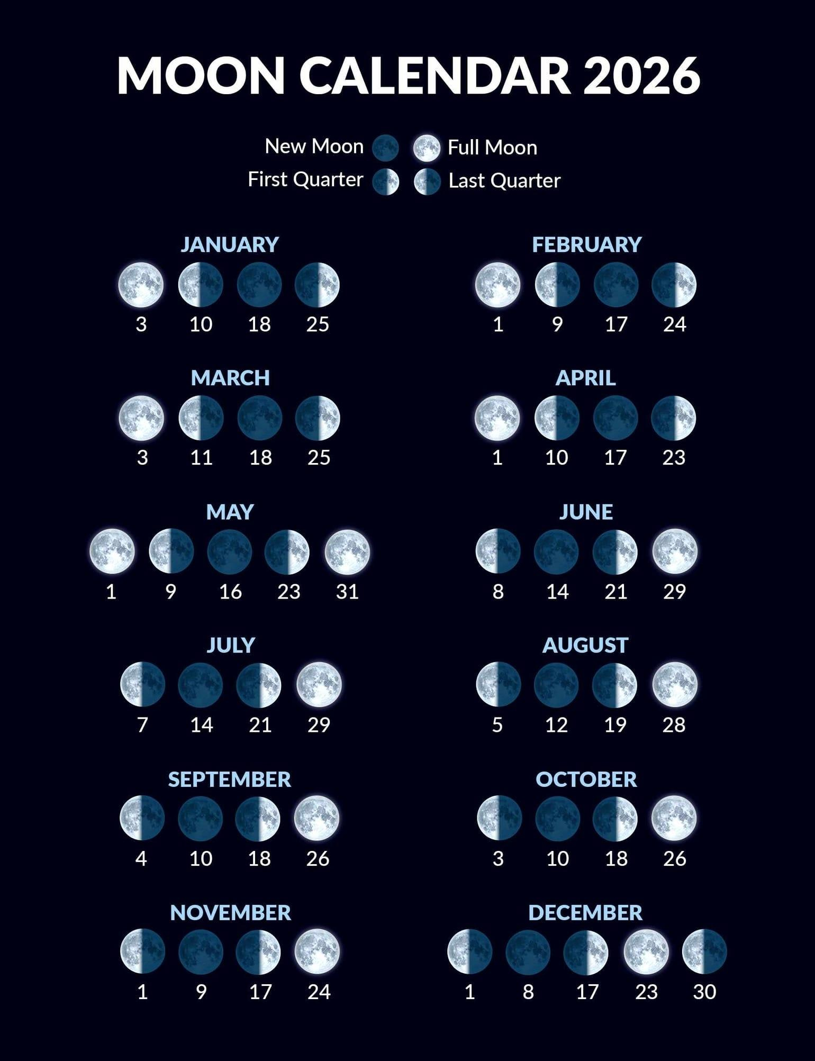
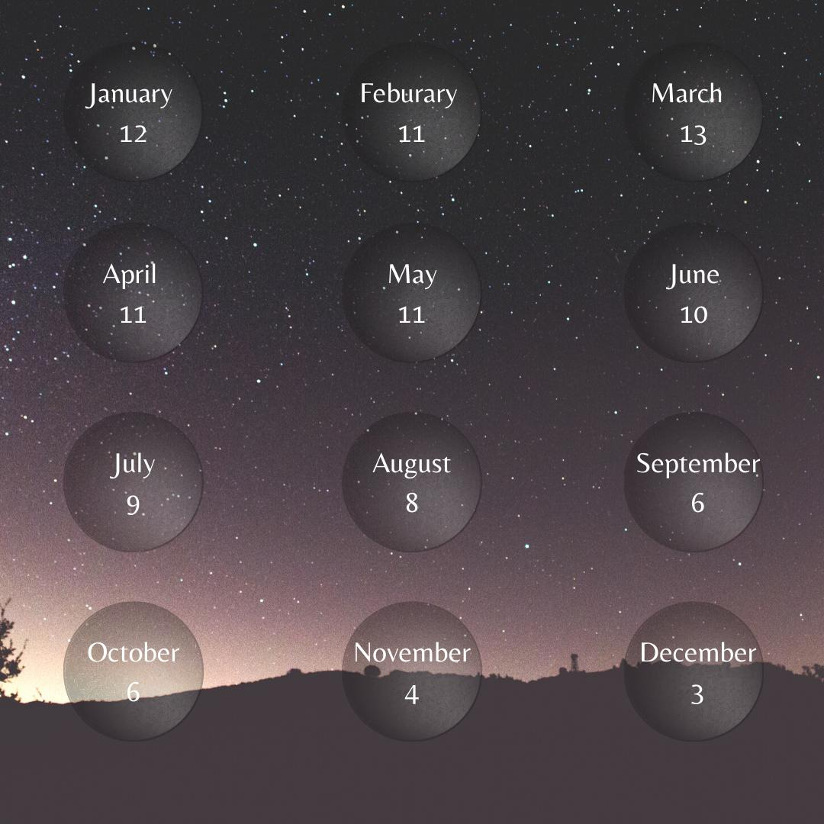
A Lunar Year is a year based on the cycles of the Moon rather than the Earth's orbit around the Sun. It consists of 12 lunar months, each beginning with a new lunar cycle. Because lunar months average about 29.53 days, a lunar year is shorter than a solar year.
The average length of a lunar year is approximately:
$$354.37\text{ days}$$
This is about 11 days shorter than a tropical (solar) year.

Definition
# Source: AI Source: Provided by: [Data Path: Persons Table -> ID Column: 1, Name_En Column: Motasem Essam] -> From: [ChatGPT] on [7/17/2026]
A Lunar Year is a year consisting of twelve lunar months, measured according to the Moon's phases rather than the Earth's revolution around the Sun.

Astronomical Basis
# Source: AI Source: Provided by: [Data Path: Persons Table -> ID Column: 1, Name_En Column: Motasem Essam] -> From: [ChatGPT] on [7/17/2026]
A lunar year is based on the synodic month, which is the time between two successive New Moons.
Average length of one lunar month:
$$29.5306\text{ days}$$
A lunar year contains:
- 12 lunar months
Therefore:
$$12×29.5306≈354.37\text{ days}$$

Average Length
# Source: AI Source: Provided by: [Data Path: Persons Table -> ID Column: 1, Name_En Column: Motasem Essam] -> From: [ChatGPT] on [7/17/2026]
A lunar year lasts approximately:
$$354.37\text{ days}$$
Equivalent to approximately:
- 354 days
- 8 hours
- 49 minutes

Structure of a Lunar Year
# Source: AI Source: Provided by: [Data Path: Persons Table -> ID Column: 1, Name_En Column: Motasem Essam] -> From: [ChatGPT] on [7/17/2026]
A lunar year contains:
- 12 lunar months
- Approximately 354 days
Most lunar calendars use months of:
- 29 days, or
- 30 days

Difference from the Solar Year
# Source: AI Source: Provided by: [Data Path: Persons Table -> ID Column: 1, Name_En Column: Motasem Essam] -> From: [ChatGPT] on [7/17/2026]
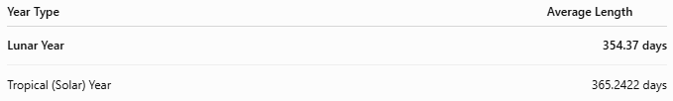
Year Type | Average Length
Lunar Year | 354.37 days
Tropical (Solar) Year | 365.2422 days

Difference:
$$365.2422-354.37≈10.87\text{ days}$$
Approximately 11 days.
Because of this difference:
- A purely lunar calendar moves earlier through the seasons by about 11 days each solar year.

Use in Calendar Systems
# Source: AI Source: Provided by: [Data Path: Persons Table -> ID Column: 1, Name_En Column: Motasem Essam] -> From: [ChatGPT] on [7/17/2026]
The best-known lunar calendar is the:
Islamic (Hijri) Calendar
- Consists of 12 lunar months.
- The beginning of each month is traditionally determined by the sighting of the new crescent Moon (although some countries use astronomical calculations).
- Religious events such as Ramadan, Eid al-Fitr, Eid al-Adha, and the Hajj are scheduled according to the lunar year.

Seasonal Drift
Because the lunar year is shorter than the solar year:
- Lunar calendar dates gradually move through all seasons.
For example:
- Ramadan may occur in:
  - Winter
  - Spring
  - Summer
  - Autumn
Over a cycle of about 33 solar years, the lunar calendar completes a full rotation through the seasons.

Applications
# Source: AI Source: Provided by: [Data Path: Persons Table -> ID Column: 1, Name_En Column: Motasem Essam] -> From: [ChatGPT] on [7/17/2026]
Lunar years are used for:
- Religious observances
- Traditional festivals
- Cultural ceremonies
- Historical records
- Astronomical observations

Advantages
# Source: AI Source: Provided by: [Data Path: Persons Table -> ID Column: 1, Name_En Column: Motasem Essam] -> From: [ChatGPT] on [7/17/2026]
A lunar year:
- Closely follows the Moon's natural cycle.
- Makes the phases of the Moon predictable within the calendar.
- Preserves long-standing religious and cultural traditions.

Limitations
# Source: AI Source: Provided by: [Data Path: Persons Table -> ID Column: 1, Name_En Column: Motasem Essam] -> From: [ChatGPT] on [7/17/2026]
A lunar year:
- Does not remain aligned with the seasons.
- Is shorter than a solar year.
- Is less suitable for agriculture without seasonal adjustment.

Comparison with Other Types of Years
# Source: AI Source: Provided by: [Data Path: Persons Table -> ID Column: 1, Name_En Column: Motasem Essam] -> From: [ChatGPT] on [7/17/2026]
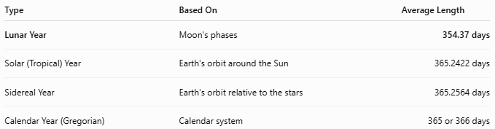
Type | Based On | Average Length
Lunar Year | Moon's phases | 354.37 days
Solar (Tropical) Year | Earth's orbit around the Sun | 365.2422 days
Sidereal Year | Earth's orbit relative to the stars | 365.2564 days
Calendar Year (Gregorian) | Calendar system | 365 or 366 days

Common Mistakes
# Source: AI Source: Provided by: [Data Path: Persons Table -> ID Column: 1, Name_En Column: Motasem Essam] -> From: [ChatGPT] on [7/17/2026]
- Confusing a lunar year with a solar year.
- Assuming lunar years remain synchronized with the seasons (they do not).
- Assuming every lunar month has exactly 30 days (most alternate between 29 and 30 days).

Interesting Facts
# Source: AI Source: Provided by: [Data Path: Persons Table -> ID Column: 1, Name_En Column: Motasem Essam] -> From: [ChatGPT] on [7/17/2026]
- A lunar year is approximately 11 days shorter than a solar year.
- Over time, this causes lunar calendar dates to cycle through every season.
- Many ancient civilizations originally used lunar calendars before developing solar or lunisolar systems.

Key Points
# Source: AI Source: Provided by: [Data Path: Persons Table -> ID Column: 1, Name_En Column: Motasem Essam] -> From: [ChatGPT] on [7/17/2026]
Key Points
- A Lunar Year consists of 12 lunar months.
- Average length:
$$354.37\text{ days}$$
- It is approximately 11 days shorter than a solar year.
- It is used primarily in the Islamic (Hijri) Calendar.
- Lunar years are based on the Moon's phases, not the Earth's orbit around the Sun.

Conclusion
# Source: AI Source: Provided by: [Data Path: Persons Table -> ID Column: 1, Name_En Column: Motasem Essam] -> From: [ChatGPT] on [7/17/2026]
A Lunar Year is a time period composed of twelve lunar months, lasting approximately 354.37 days. Since it is based entirely on the Moon's phases, it is about 11 days shorter than the solar year and gradually shifts through the seasons over time. Lunar years remain an essential part of many religious and cultural traditions, especially in the Islamic (Hijri) Calendar, where they determine the timing of important observances and festivals.

